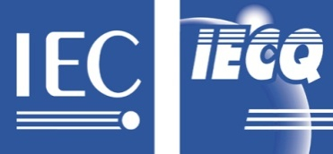 |  | IEC QUALITY ASSESSMENT SYSTEM (IECQ)  covering Electronic Components,  Assemblies, Related Materials and Processes  For rules and details of the IECQ visit www.iecq.org
Schedule of Scope to Certificate of Conformity
Hazardous Substance Process Management
IECQ Certificate No.: IECQ-H TUVSUDSG 09.0002
CB Certificate No.: QC-2008-0001
Schedule No.: IECQ-H TUVSUDSG 09.0002-S |  |  | Rev No.: 1 | Revision Date: 2011-02-10 | Page 1 of 1
Issue to : UNISTEEL TECHNOLOGY (M) SDN BHD
No.2, Jalan Mega 1
Taman Perindustrian Nusa Cemerlang
79200 Nusajaya
Johor Darul Takzim

Process or service in respect of which the company is Certified:

Design, Manufacture and Supply of Precision Cold-Formed Fasterners & Coiling Products

Process Detail(s)/Location(s):

- The organization subscribes to the elements as follows :

- Cadmium
- Chromium (VI)
- Lead
- Mercury
- PolyBrominated Biphenyls (PBB’s)
- PolyBrominated Diphenyl Ethers (PBDE’s)
- Customer-Specific Requirements for Hitachi Global Storage Technologies, Seagate
Technology, Western Digital, Toshiba Storage Products Company

- The Scope covers the activities at the following locations :

- UNISTEEL TECHNOLOGY (M) SDN BHD
No.2, Jalan Mega 1, Taman Perindustrian Nusa Cemerlang, 79200 Nusajaya
Johor Darul Takzim
– Main Operations, Design and QA Functions.

- UNISTEEL TECHNOLOGY (M) SDN BHD
No.15/17, Jalan Mega 2, Taman Perindustrian Nusa Cemerlang, 79200 Nusajaya
Johor Darul Takzim
– Warehouse/Store for Raw Materials and Finished Goods Storage.

- UNISTEEL TECHNOLOGY LIMITED
67 Ubi Avenue 1 #02-08/09 Starhub Green, Singapore 408492
- For Sales and Marketing Function.

